Parker D. Lewis
Dr. Paul King
Nuclear Grad Lab
9/10/24

Tutorial Analysis assignment

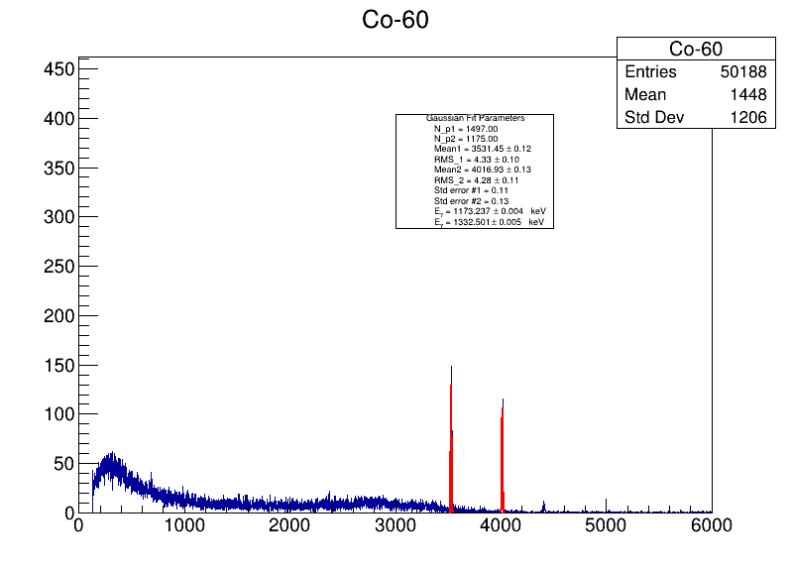

Fig 1. Cobalt-60 Data and Histogram.

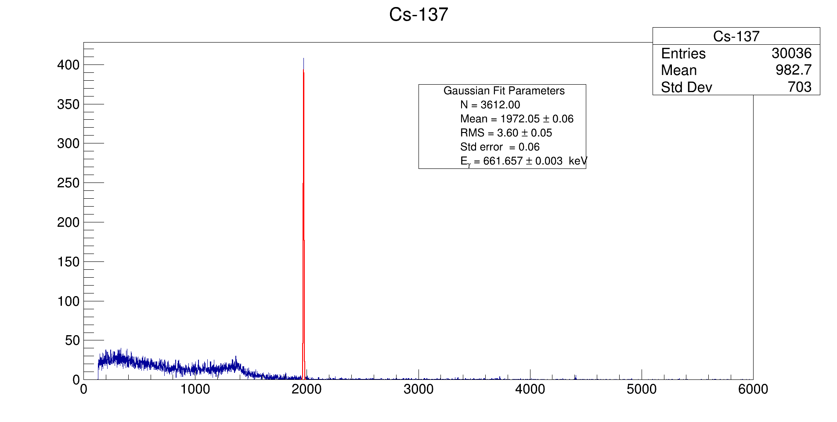

Fig 2. Cesium-137 Data and Histogram.

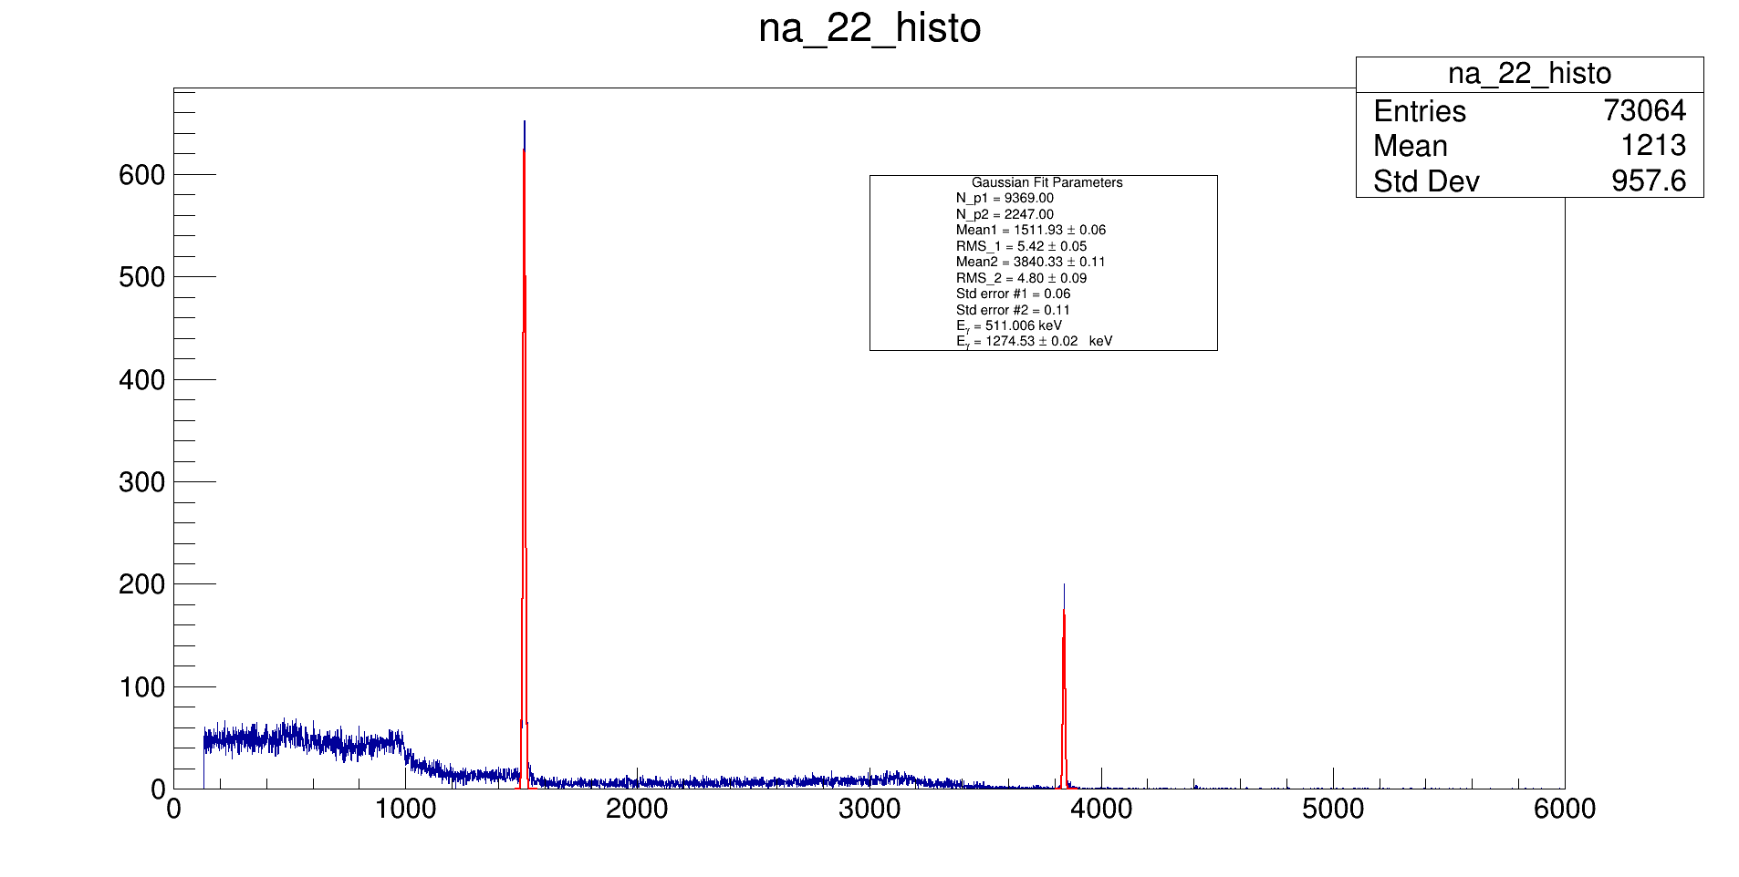

Fig 3. Sodium-23 data and histogram.

- For all three histograms, I found the parameters and needed values by taking the information from the gaussian fits. I also used the integral method in root to find my number of counts and defined the formula of error of the mean to get those values of my peak. I used the Idaho National Labs source for the gamma energies.

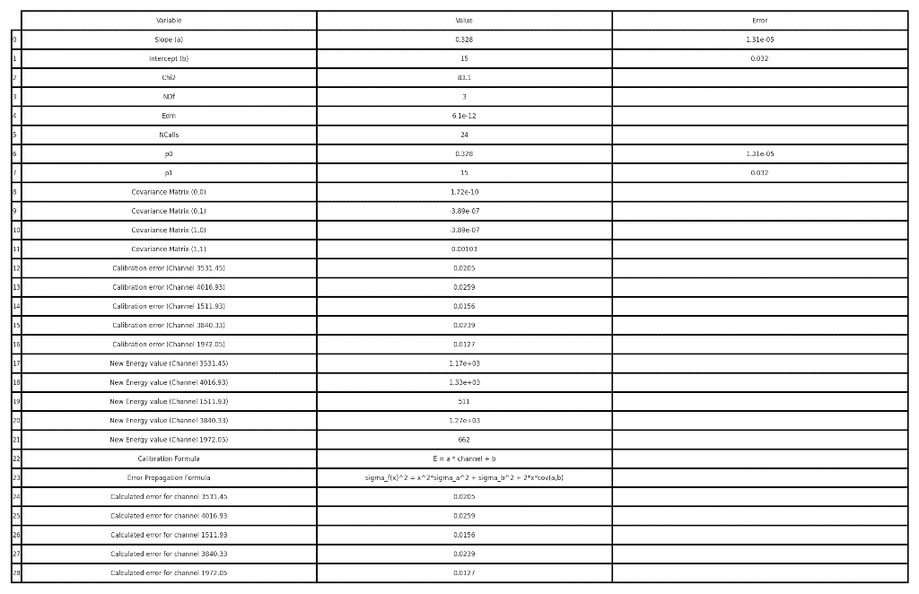
Fig 4. Energy Calibration Formulas, Parameters, and Errors.

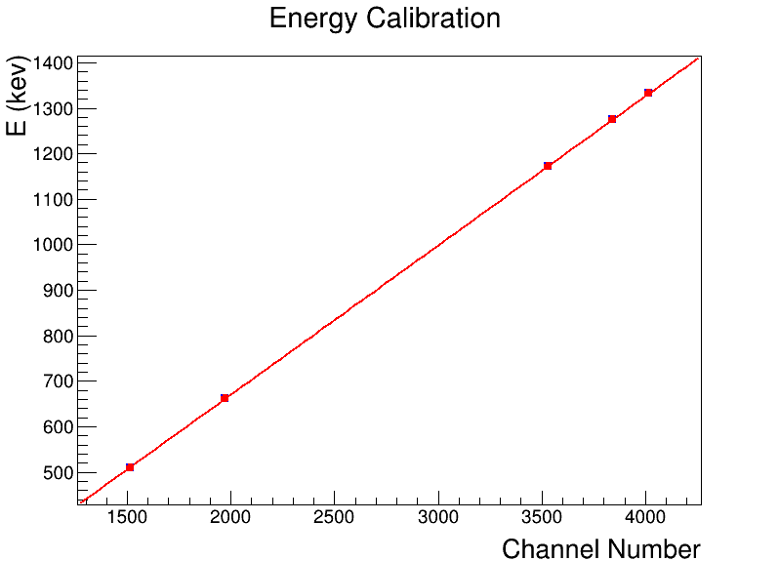
Fig 5. Energy Calibration Plot.

- Using gamma energies, mean channel numbers, uncertainties of both, I used TGraphErrors, and linear fitting to get a calibration plot, calibration formula, uncertainty relations, formula, and the rest of the parameters requested.

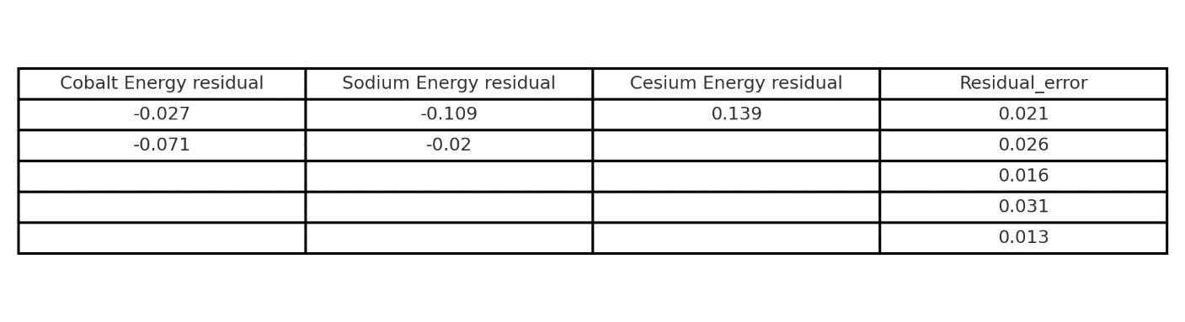
Fig 6. Energy Residual and Uncertainties of Na-22, Cs-137, Co-60.

$σ=\sqrt{σ_{f}+σ_{L}}$ (1)
Fig 7. Residual Uncertainty.

- The residual has higher value than the calibration error values. This means that other factors like systematic errors in measurements, lack of consistency within a model to predict behavior and fit a data set.

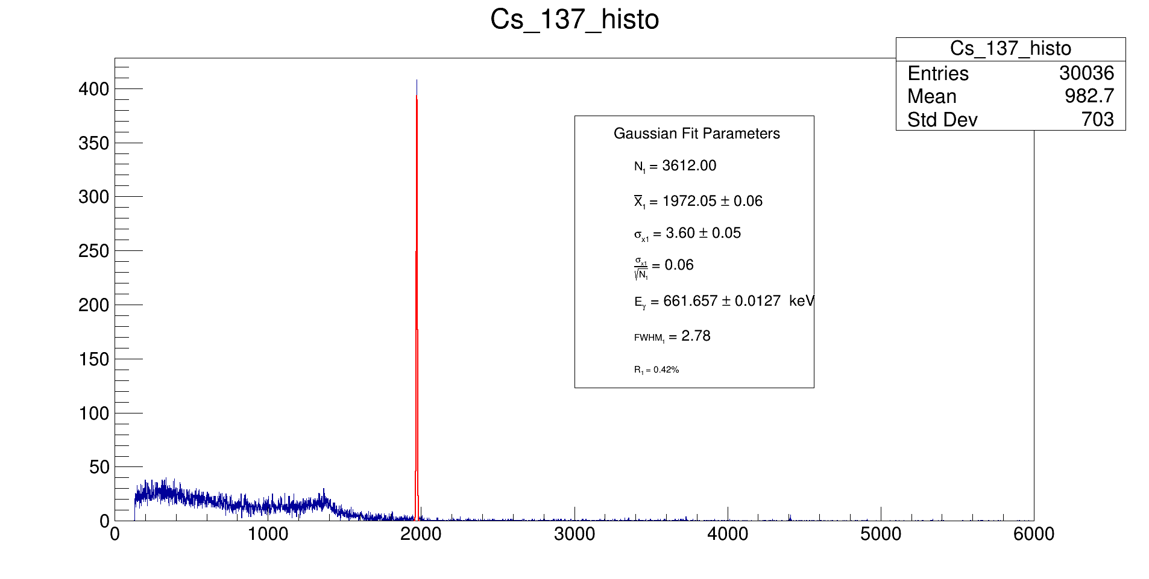

Fig 8. Cs-137 Parameters, FWHM, Resolution.

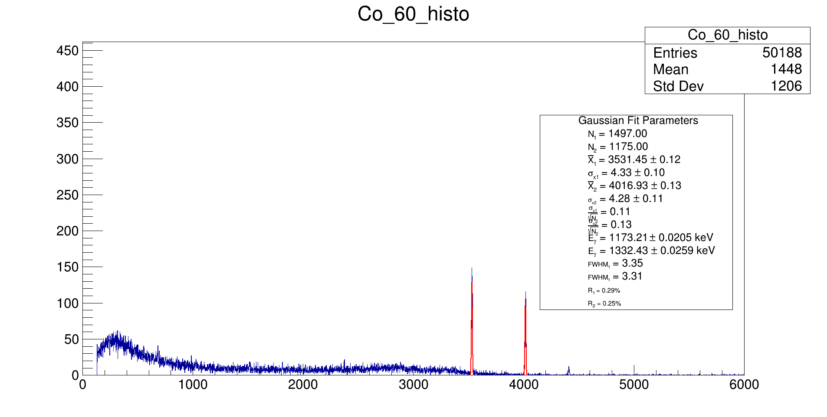

Fig 9. Co-60 Parameters, FWHM, Resolution.

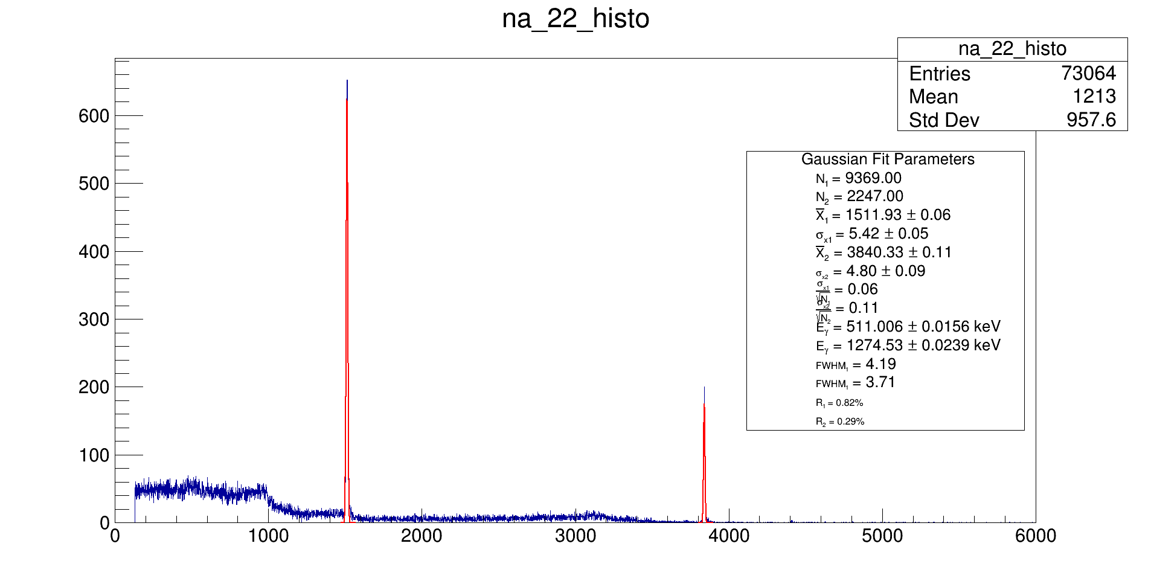
Fig 10. Na-22 Parameters, FWHM, Resolution.

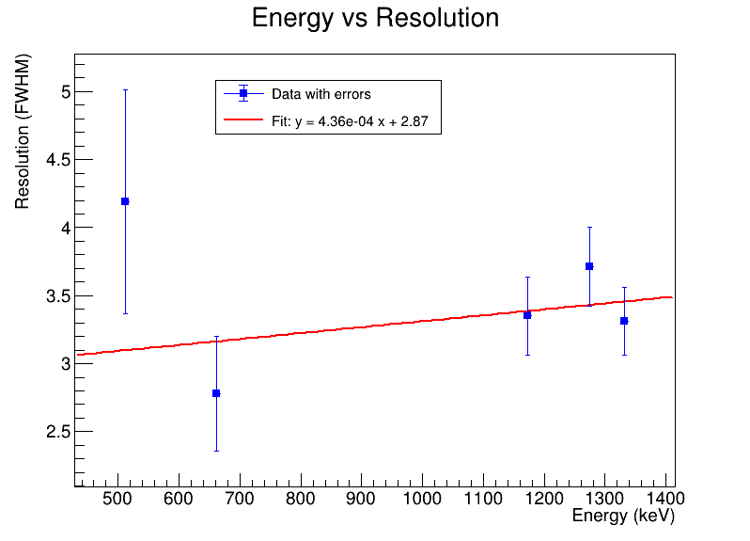
Fig 11. Energy vs. Resolution Plot.

- I analyzed the energy resolution for isotopes such as Cobalt-60, Cesium-137, and Sodium-22 by using Gaussian fits on their respective energy histograms. From these fits, I extracted key parameters like the full width at half maximum (FWHM) and peak positions. I then used these values, along with their uncertainties, to plot the relationship between energy and resolution.
- I incorporated error bars to represent uncertainties in both energy and resolution. To further understand the relationship, I applied a linear fit to the data points, creating a model to describe how resolution varies with energy.
- Since The plot is flat it’s keen to say that Energy resolution doesn’t vary much with energy or dependent on it.

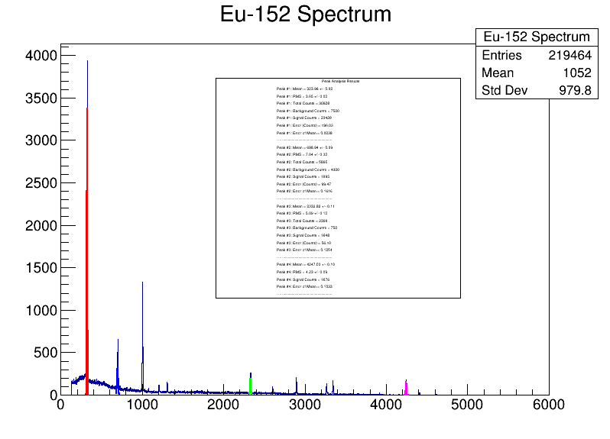
Fig 12. Parameters of Eu-152 Spectrum.

- I used a Gaussian fit for my 4 peaks to get the RMS, mean, and total counts. I did a constant curve on each peak and applied an integral method to get background count. I got signal count by subtracting total and background, and I did the square root of background and total to get counting error. I then got error of the mean by mean from Gaussian fit divided by square root of signal.

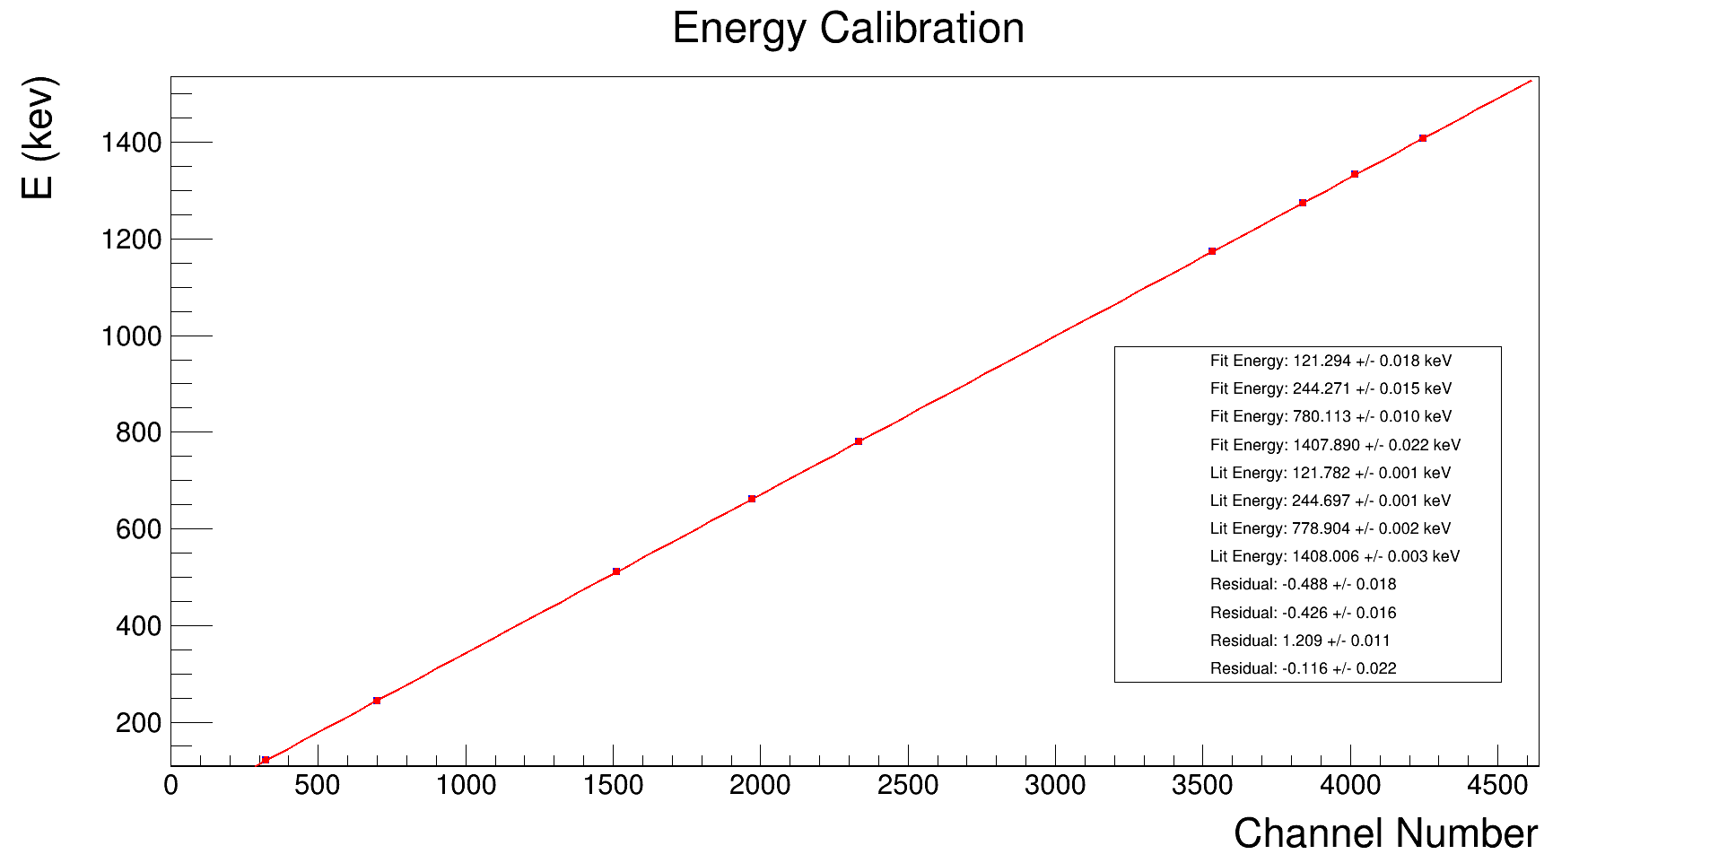
Fig 13. Calibration and Parameters of all Spectra.

- I applied the calibration and uncertainty techniques of questions 2&3 to get the residuals, residual uncertainties, fit energies, and fit uncertainties. I also used the same source of the Idaho page.

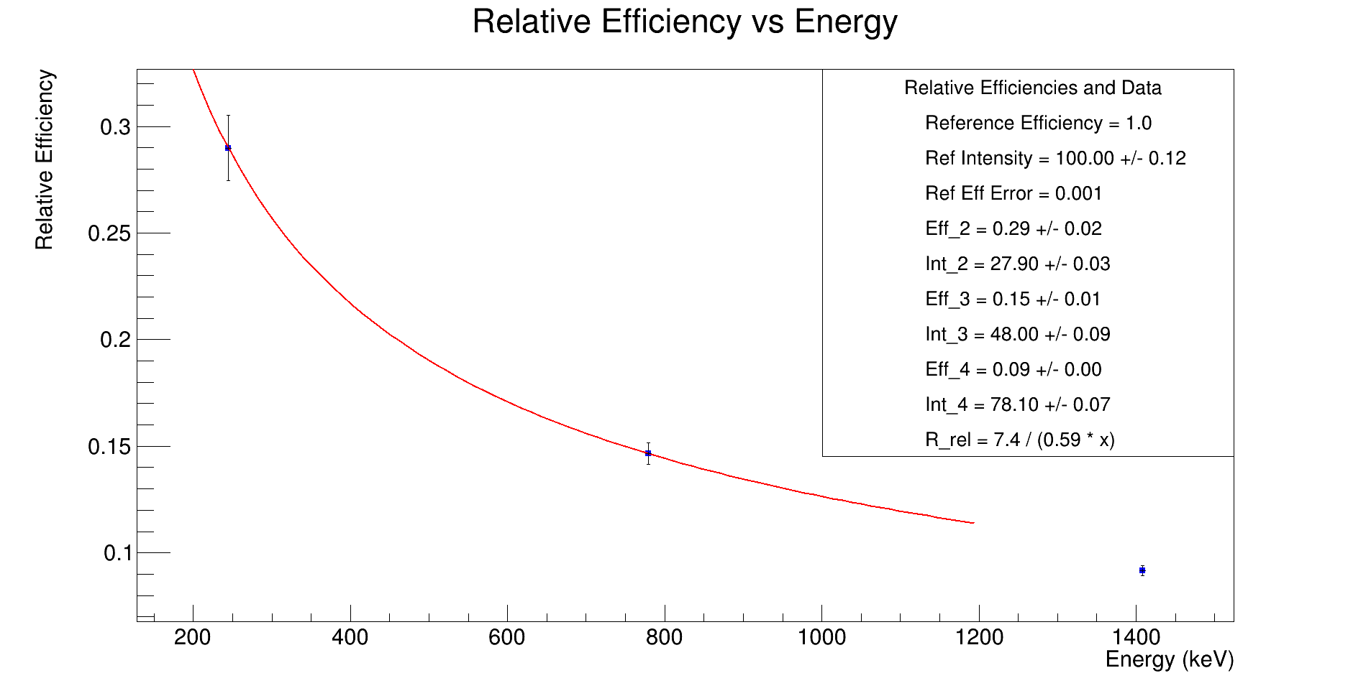
Fig 14. Relative Efficiency Curve and Parameters.

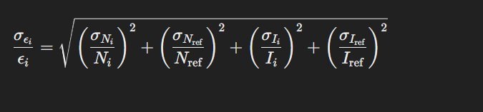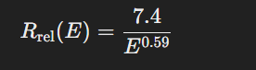
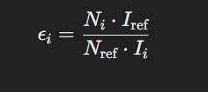
Fig 14. Equation Schemes for The Analysis.

- I calculated the relative detector efficiency for Eu-152 by analyzing the peak intensities provided by Idaho source and counts of several prominent peaks. First, I defined a reference peak, using its total counts and intensity to compare with other peaks. For each additional peak, I calculated its relative efficiency by comparing the ratio of counts to the reference, adjusted by their respective intensities.
- To propagate uncertainties, I accounted for errors in the counts and intensities of both the reference and the other peaks. Using error propagation formulas, I calculated the uncertainty in the relative efficiency for each peak. The results were then plotted as a function of energy, with error bars representing the efficiency uncertainties. I also fit a polynomial decay functional form to the data to model the relationship between energy and detector efficiency, providing a mathematical description of how the relative efficiency varies with energy.

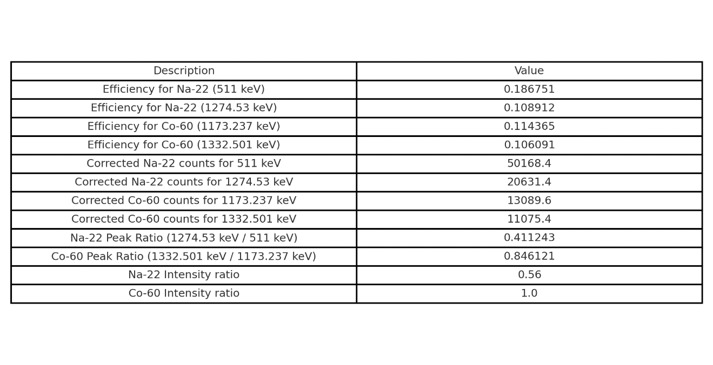
Fig 15. Parameters: Efficiencies, Corrected Counts, and Ratios.

- In this analysis, I measured the event counts for two peaks from the Na-22 and Co-60 calibration spectra and applied a correction using the relative efficiency function derived from prior work. The efficiency for each energy peak was calculated using a power law model, and I corrected the event counts by dividing the measured counts by the respective efficiencies. After obtaining the corrected counts, I calculated the ratio of the two peaks for each isotope. Finally, I compared these ratios to the expected intensity ratios based on literature values to assess how well the corrected data matched the known standards.

- By comparing the ratios, they are off from around a range of 15 to 35 % difference. It could mean in earlier work by pre-corrected counts could be off and maybe with some issues of the power law not totally predicting efficiencies correctly either.

Work Cited

[1]. “Ray Spectrometry Catalog &nbsp; // .” Gamma, gammaray.inl.gov/SitePages/Home.aspx. Accessed 10 Sept. 2024.

